Adrian Rivera

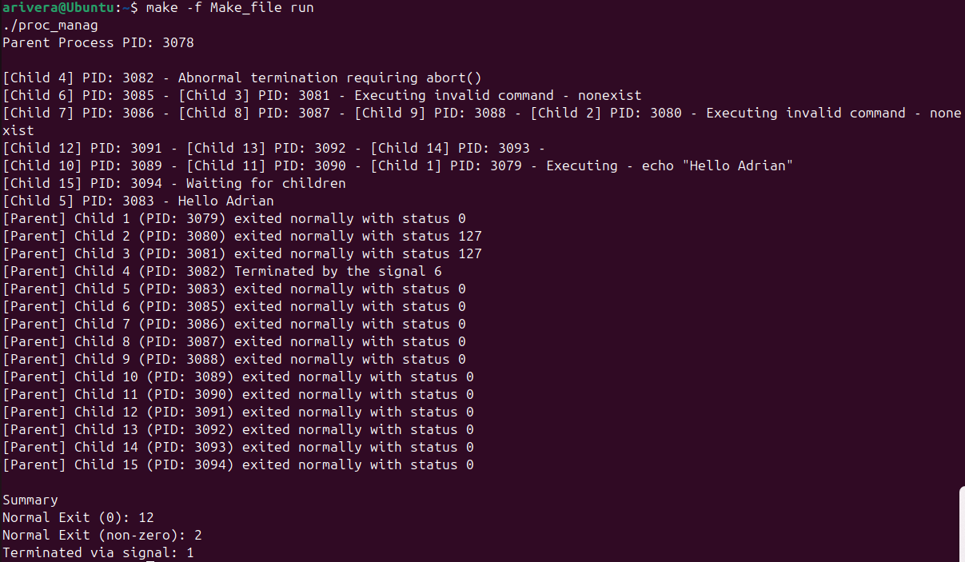

Process management for operating systems is a core functionality that handles creation, scheduling, execution, and termination within the system to ensure that the system’s resources are used efficiently. It also allows multiple programs to run at once as well as managing process states and context switching handling. Scheduling allows for specific processes to be run on the CPU and determines how long to run them for, allowing for the most usage of the CPU itself. Context switching allows for states of a running process to be paused and allows another to be loaded which allows for multitasking. There is also Interprocess Communication which provides mechanisms for processes to exchange data and coordinate.

My program defines the number of children that will be created with a maximum of 15, while also counting the number of normal exits with and without 0 as well as how many were signaled for exit. A parent is created and assigned a parent ID, after this the children are created, the first of which echo’s “Hello Adrain” while also giving it a PID. Fork() is used to duplicate the process, making the original process the parents and the newly created one the children. The execvp() allows for a current running process to be replaced with a different one, in the case for my code it allows for the program to switch between running different tasks such as echoing “Hello Adrian” or running the intentional invalid commands or abnormal relation. When waitpid() is run it suspends the execution of the parent process until the child process state changes, in this case it will wait until the parent and or child process finishes its execution and reports its status up until child 15 is reached. At the bottom of my code a summary is printed out to show how many exit codes were normal 0 exits, non-zero exits and how many were signaled to terminate.

The children processes were created and their PID were managed via the kernel, the parent was created and given a PID from the kernel, after this when a child is created it is given a PID that is incremented by 1. The creation is done sequentially based on the previous PID and the termination was based on the current PID and when the process status was determined. A child is determined to have exited normal or by a signal based on if it was returned by the main, if it was, the code checks if it exited with a 0, 1, or 127, if it did not return from main it is then deemed as a signal termination.

I learned a good amount when it comes to Unix process management, it was interesting to see each parent and child appear and give its status on if it exited normally or if it did not. Considering as well the PID was never always the same since it is determined by the kernel on what it is assigned. While I did have some problem getting the Make_file to run initially I did find a solution that allowed it to run as intended which gave me valuable insight on how to specify a make file to run.

